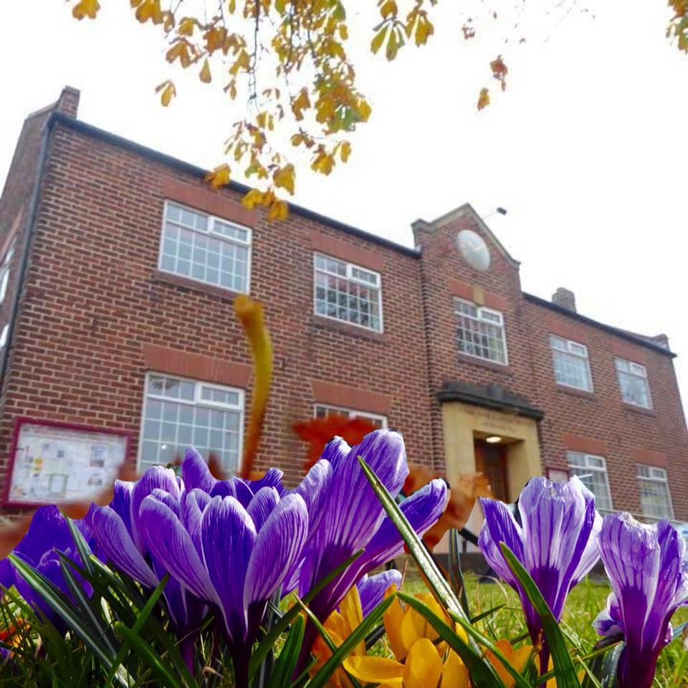

Chair’s Annual Report October 2019

Coxhoe Village Hall Association
Chair’s Annual Report 2019
This is my seventh year as Chairman and I continue to be extremely proud of the achievements of a small but hard working committee and staff. I am delighted to report that we have had a sustained year of improvement.
Achievements
This year has seen us achieve the following:-
Support from Wates Construction Group.
People may recall Wates Construction of which I am an employee has in previous years provided resources and materials, during their Community Week. I am delighted to confirm that their support this year has been fantastic. They have provided advice and support with the long-standing aspiration of the community, demonstrated in Parish Plan 1 and 2, to make the upstairs of our facility accessible to all.
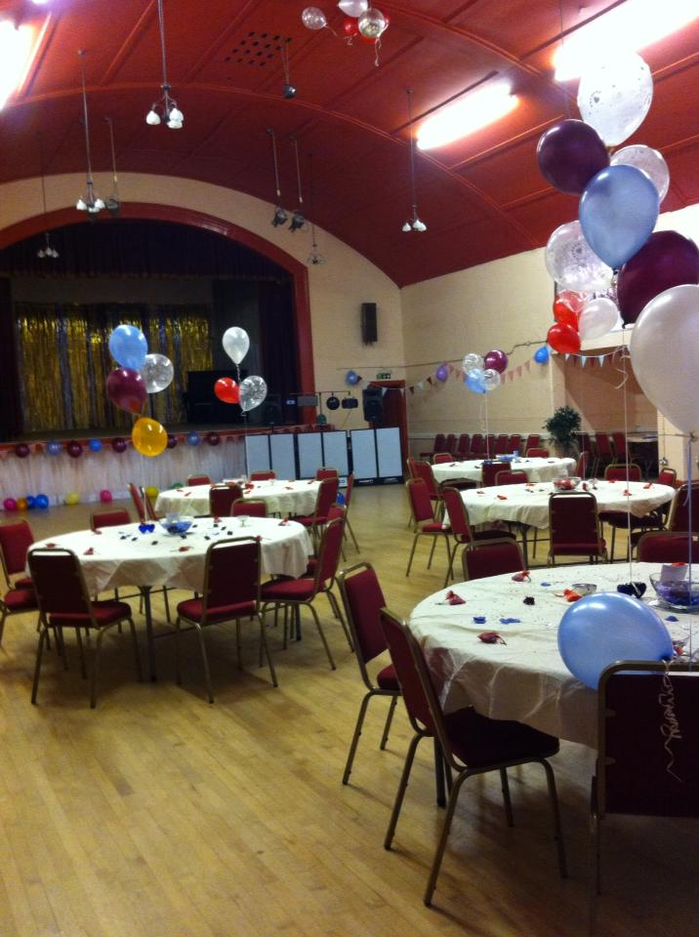
We are delighted to have secured a reclaimed through floor lift (2 years old) and had it professionally dismantled and transported to the Hall. Wates have committed to providing help and resource in order to have the lift installed and ensure its compliance with the regulations.
Approval to install the lift was received from Coxhoe Parish Council in accordance with the terms of the lease, following a special meeting held on the 25th September 2019. We are grateful to all Parish Councillors for reaching this positive decision for the Community Association and users.
Funding applications
Many will recall that we received a report and recommendations from Durham County Fire Brigade. Compliance with the recommendations was, however cost prohibitive. We are pleased to confirm we have submitted a funding application for £6,000 to install a fire alarm system and emergency lighting throughout, to the East Durham Rural Corridor Area Action Partnership. We are delighted to confirm that we have had verbal confirmation that this has been approved.
The provision of first floor access and compliance with fire requirements have been two longstanding major projects which the Village Hall Committee are delighted to have brought to fruition.
The provision of a safer and more accessible building is a big step to providing a sustainable future for the Village Hall in the 21st century.
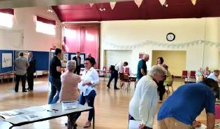
The committee have been actively securing quotations for the refurbishment of the toilets in readiness for a future funding application.
Support from others
The Parish Council in response to the Parish Plan 2 continue to assist and support the running of the Village Hall with a £4,000 grant, for which we are extremely grateful.
The ladies club kindly selected the village hall and donated £1,000 at the very enjoyable Strawberry fair which Nicola and I attended.
In partnership with Age Concern, and supported by the AAP and County Councillors we have this year launched the luncheon club which is providing lunch and company for approximately 20 people. this is another community aspiration from Parish Plan 2.
Coffee and a catch up have been launched this year providing interaction for the community for an average of 15 people. We have a funding application in for board games etc to support this activity.
A men’s club and carpet bowls is currently under review.
Accounts
Karen Williams has now supported the village hall for over a year and now delivers an effective service .
We are pleased to advise that our accounts have been fully audited and along with the Chairman’s report will be submitted to the Charities Commission. Thank you to David Nichol for again auditing our accounts which he does year on year free of charge.
We are pleased to confirm that this year we have for the third year balanced our books and managed to build and sustain a reasonable level of reserve. This level of reserve is still below that recommended by the Charities Commission for an organisation of our size, but represents a year on year improvement.
Our Statement of Accounts is displayed on the notice board should anyone wish to view it.
User Groups
We continue to be amazed at, and are grateful for, the numbers and diversity of people and activities using the village hall. We continue to host everything from, Weddings, Birthday’s, Funeral’s, Dance shows etc.
Committee
The current committee is relatively small but hard working bunch and I personally thank you all for your support and commitment.
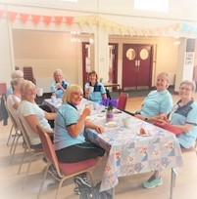
Nicola Dodsworth, our secretary, who resigned from paid employment and now devotes countless hours, to what sometimes can feel like a thankless task. However, she does so, with a smile and a positive attitude.
Staff
Derek Orton – Caretaker, who is loved by all the user groups.
Shirley Armstrong – who offers support and help all year.
Casual Bar staff – Have supported us through the various and varied events we have held in the hall. Weddings, Funerals, Christenings, Party’s, Fairs, Choir concerts, Christmas carol concerts to name but a few.
We thank the team for their contribution.
Volunteers
Ian Forster continues to update and improve our website and social media for which we thank him.
Friends of the Village Hall
Small in number but we as a committee we appreciate the help they provide.
The book club team continue to provide a great service and raise circa £1,000 for the village hall.
Challenges for 2019 and beyond
There must be a concerted effort to encourage people to actively get involved with the running of the Village Hall.
We have a large and increasing size of community and undoubtedly within the community there must be people with skills or just energy and time who could contribute something to improving the hall for the benefit of the community. The current committee is too small and needs to be freshened up with people who are prepared to run with actions and get involved.
We must continue to submit funding applications to improve the hall. Ambitious plans to increase the Halls size are on hold until the committee is adequately resourced and supported.
Last year Nicola and I put the community on notice of our intent to stand down at the next AGM. We have personal plans which we want to go off and enjoy. Our commitment to the community is to work alongside the new committee as friends of the village hall to support the install of the lift and the fire alarm and ensure a smooth transition.
It is time for the Wider Community to get involved.
Partnership Working
Karen Williams, employed as part of our continued partnership with Coxhoe Parish Council, deserves special recognition and appreciation, and has lightened the workload for the committee.
Conclusion
The committee is proud to have delivered another positive annual report. We have made steady controlled progress targeting two major projects, and achieving the aspirations for a luncheon club.

Paul Dodsworth
Chair Coxhoe Village Hall

